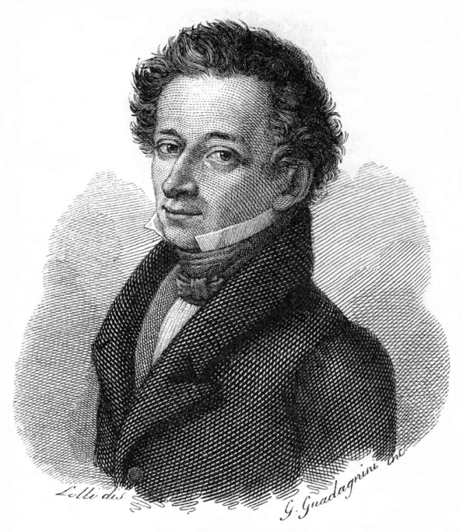**A Translation of Giacomo Leopardi’s**

**“L’Infinito”**

Giacomo Leopardi was born in Recanti, a town near the Adriatic coast in Italy. With an insatiable craving for learning, Leopardi spent his teenage years studying alone, after his private tutor prematurely concluded that “his own scholarship was inferior to [Leopardi’s]”. Unsupervised, he spent a preponderance of his time looking over the texts of his family palace’s twelve-thousand book library.

I think this poem fits in well with the Enigma’s theme of ‘Classics’. Renowned as one of the greatest Italian poets of all time, Leopardi has cleverly labelled his poem as “L’Infinito”, or simply “Infinity”. The poem itself is what one would call a ‘classic’, something that transcends time and continues to be relevant to readers of any generation, but the title of “infinity” suggests that Leopardi was aware this poem would be something for the ages. Despite anyone’s best attempts, it is impossible for nothing to be lost in translation. There are some words which do not directly translate from Italian to English, such as “sovrumani” in line 5, which in English essentially means ‘more than human’. It is almost impossible to convey the original meaning that Leopardi intended, but through a limitation in English linguistics there is only so much translations can provide.

*L'infinito  
  
Sempre caro mi fu quest'ermo colle  
E questa siepe che da tanta parte  
De'l ultimo orrizonte il guarde esclude.  
Ma sedendo e mirando interminati  
Spazi di la da quella, e sovrumani  
Silenzi, e profondissima quiete,  
Io nel pensier mi fingo, ove per poco  
Il cor non si spaura. E come il vento  
Odo stormir tra queste piante, io quello  
Infinito silenzio a questa voce  
Vo comparando; e mi sovvien l'eterno,  
E le morte stagioni, e la presente  
E viva, e'l suon di lei. Cosi tra questa  
Immensita s'annega il pensier mio:  
E'l naufragar m'e dolce in questo mare.*

*Infinity*

*Always dear to me, was this lonely hill*

*And this hedge, that so much*

*Of the farthest horizon is excluded from my sight.*

*But as I sit and look, boundless*

*Spaces are beyond that, and superhuman*

*Silences, and the deepest quiet*

*While in my thoughts I pretend; where for a little*

*The heart is overwhelmed. And like the wind*

*I hear rustling among the plants, I compare*

*The infinite silence to this voice*

*In comparing: I am reminded of the eternal,*

*And the dead seasons, and the one present*

*And alive, and the sound of it. So through this*

*Immensity my thought is drowned:*

*And to shipwreck for me is sweet in this sea.*

I ponder what message Leopardi is attempting to communicate through his tantalizing writings. Perhaps the poem is about the psychology of aesthetic experience, but as Gabrielle Sims so eloquently puts it, “One hesitates to say what the poem is about.” The poem’s purpose is unknown, and it is up to the reader to decide what its meaning is.

Interestingly though, in much of Leopardi’s other poetry, he stresses his belief that joy is nothing but the momentary absence of pain, and that only in death can man find lasting happiness. However, from time to time Leopardi provides statements which vaguely balance his quite pessimistic view, as seen in the last line of “L’infinito”- in its original Italian, “E il naufragar m’e dolce in questo mare,” translated as “And to shipwreck for me is sweet in this sea.” These statements reveal a different aspect of Leopardi’s work and personality; we can see that he is not the typical optimist, but rather an enraptured admirer of nature’s beauty, and a believer in the power of imagination.

Leopardi called “L’ifinito” an ‘idyll’, an idealized situation, and this locus perfectly fits the charm of this poem. Renato Poggioli, and Italian academic, wherefore states that the poem “makes familiar, and almost dear to the heart of man, the alien metaphysical vision of a universe ruled by laws other than those of life and death.”